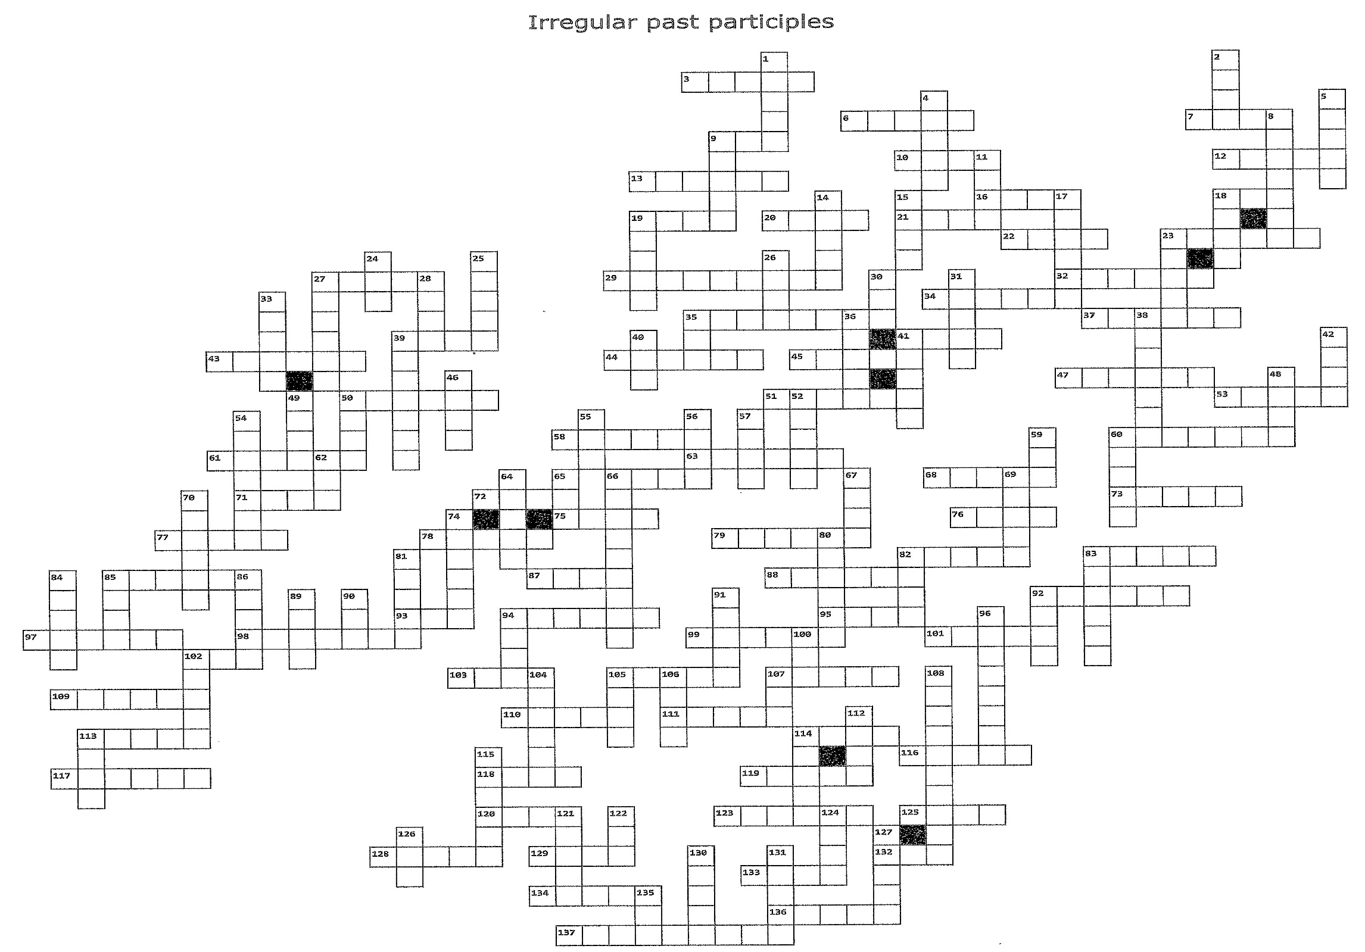

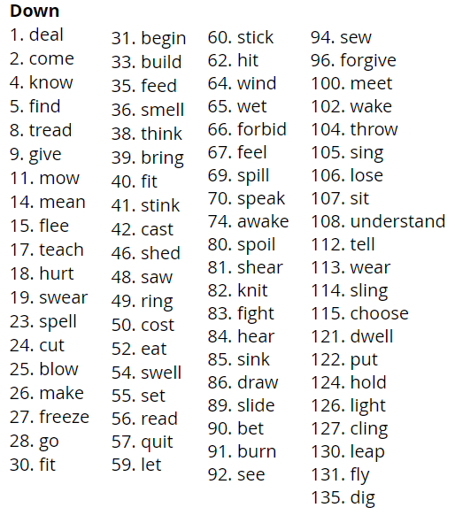
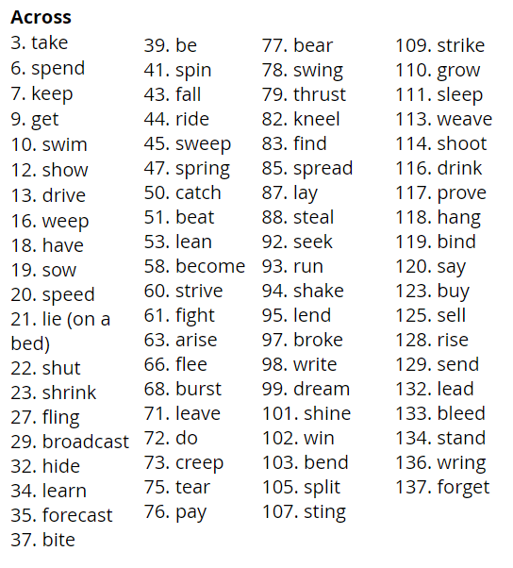

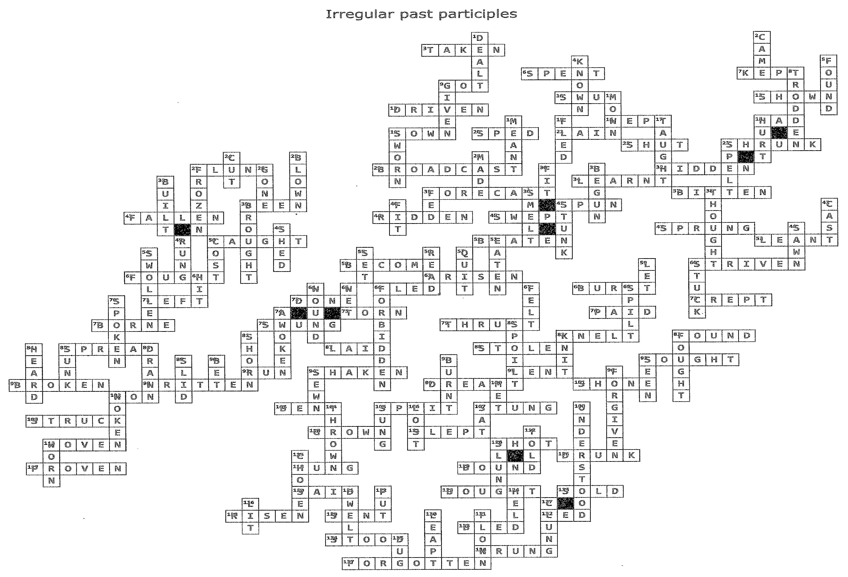
Notes:
- These verbs have two past participle forms, the alternative mainly used in American English, but is also used in British English but in slightly different contexts:
burnt/burned, dreamt/dreamed, dwelt/dwelled, fit/fitted, hang/hanged, knelt/kneeled, knit/knitted, leant/leaned, leapt/leaped, learnt/learned, lit/lighted, mown/mowed, proven/proved, sawn/sawed, sewn/sewed, shorn/sheared, smelt/smelled, sown/sowed, sped/speeded, spilt/spilled, spoilt/spoiled, swollen/swelled, woven/weaved, woken/waked, wet/wetted.
- When ‘lie’ means to deliberately say something that is not true, the past participle is then regular (lied).
- ‘Read’ in the past participle is pronounced ‘red’.

With thanks to the irregular verb list featured in Professor Martin Hewings’ excellent book, ‘Advanced Grammar in Use’, published by Cambridge University Press.

